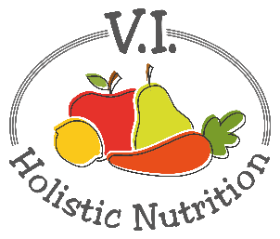
BANANA CHIA PUDDING
Here’s a recipe from The E2 meal planner.
Banana pudding is a childhood favorite. This pudding is creamy, sweet, cool and satisfying. It's also full of omega-3s, fiber, and great, natural flavor. You'll be licking your spoon and maybe even the bowl it's so good.
Makes 1 medium sized Serving
Ingredients:
- 1 banana
- ½ Tbs. chia seeds
- 1/8 tsp. cinnamon
- ½ cup rolled oats
- 2 Tbs. walnuts
- ¾ cup purified water
Method:
- The night before, mix the oats and chia seeds together in a container with a cover. Add water and mix completely, so the chia seeds are not stuck together. Soak overnight in the fridge.
- The next morning, chop the banana in half. Mash half the banana until it’s a puree. Mix this in with cinnamon and the oat-chia mixture. With the remaining banana, chop it into bite-sized pieces.
- Add the chopped banana and walnuts to the oats. Add extra liquid to the oats if needed.

