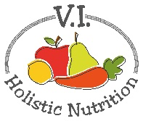
BASIC CHIA PUDDING
This adapted recipe, and its variations, is from the book Living Candida Free. It is raw and contains no sugar so it is a great dessert when you are craving something sweet but need to avoid sugar.
I make each pudding in a mason jar and store in the fridge so they are ready to go. Also, the longer they sit in the fridge, the firmer they become. Each jar contains 2 servings.
Basic Vanilla Chia Pudding
- ¼ cup (60 ml) whole chia seeds
- 1 cup (250 ml) almond or another nut milk
- 1 tsp. (5 ml) pure vanilla extract
- Pinch of fine sea salt
- 10 drops plain liquid stevia, or to taste
Combine all ingredients in a medium sized mason jar. Seal and shake. Store in the fridge overnight. Shake or stir before serving.
Variations:
Lemon Chia Pudding: Add the zest of ½ an organic lemon to the pudding with the other ingredients. Increase stevia to 15-20 drops or to taste.
Chocolate Chia Pudding: Add 2 tablespoons (30 ml) raw cacao powder with the other ingredients. Increase stevia to 20 drops or to taste.

