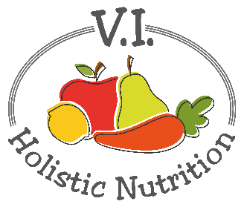
CHUNKY CHILI
Here’s another variation of an Engine 2 recipe. Each bowl of this delicious and chunky chili provides a complete protein, helping to ensure that you'll get an adequate amount of the essential amino acids to maintain your health. Eating grains with beans or lentils is the easiest way to get complete proteins in your diet on a regular basis. The canned black beans in this recipe are packed with iron, a mineral that helps transport oxygen throughout the body. Iron absorption is enhanced when paired with acidic foods, so here we've combined beans with tomatoes - a pairing that's sure to please your body and your taste buds. Makes 1 medium serving.
Ingredients:
- ¼ cup quinoa
- 1 can no-salt diced tomatoes
- 1 bell pepper, diced
- 2 cups spinach
- ½ cup water
- ¼ tsp. chili powder
- ¾ tsp. cumin
- ½ tsp. cocoa powder
- ½ can no-salt canned black beans, rinsed or 2/3 cup premade
- Sea salt and pepper to taste
- Optional top with ¼ avocado, sliced lengthwise

Method:
- In a medium pot, add the quinoa, canned diced tomatoes, frozen bell peppers, spinach, water, chili powder, cumin, and cocoa powder (if using). Mix everything together and cover.
- Cook over low-medium heat for 20 minutes or longer.
- Add the rinsed beans in about 10 minutes before serving. The idea is to heat the beans without cooking them further, because you don't want mushy beans!
- The chili is ready when everything is heated all the way through. Salt and pepper to taste and serve with avocado, if desired.

