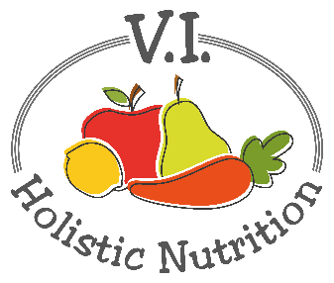
EASY PINTO BEAN PASTA
Here’s another adapted recipe from Engine 2. Packed with fiber, whole grains and plenty of flare, this is a dish that satisfies and shows how simple healthy eating can be! Makes 1 medium serving.
Ingredients:
- ½ cup whole grain or gluten free pasta
- A little purified water for ‘frying’
- ¼ onion, diced
- 1 clove garlic, finely chopped or minced
- ¼ tsp. cumin
- ½ tsp. chili powder
- ½ tomato, diced
- ½ small zucchini, diced
- ½ can pinto beans, rinsed or 2/3 cup premade
- ¼ cup cilantro leaves, chopped
- Sea salt and pepper to taste
Method:
- Cook the pasta as directed on the package.
- Add a little water to a pot and bring to medium heat. Add the onion and cook for about 5 minutes.
- Stir the garlic, cumin, and chili powder into the onions. Then, add the veggies and beans, cover the pot, reduce the heat to low, and cook for 5-10 minutes, stirring occasionally.
- Add the cilantro to the vegetables. Stir until evenly mixed. Serve the vegetables over the whole grain pasta, and add salt and pepper to taste.

