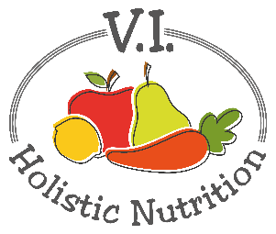
FAST RED BEANS AND RICE
Here’s another recipe from Engine 2 which I have altered slightly. Iron and protein-rich beans combine with whole grain pre-cooked brown rice, peppers and fresh spinach for a healthy, veggie- and spice-packed meal. Makes one medium serving.
Ingredients:
- 1 cup precooked brown rice
- ½ red, green or yellow pepper, diced
- 1 clove garlic, diced finely
- Water instead of oil for ‘frying’
- ¼ tsp. chili powder
- 1/8 tsp. cumin
- ¼ tsp. dried oregano
- 1/8 tsp. dried thyme
- ½ can kidney beans, rinsed and drained
- 1 Tbs. tomato paste
- Sea salt and pepper to taste
- ¼ cup fresh parsley, chopped
- ½ cup fresh spinach, chopped
Directions
- Steam to heat the pre-cooked brown rice.
- Bring a pot with a lid up to medium heat with a touch of water. Add the peppers and cook until softened. Stir in the garlic, chili powder, cumin, dried oregano and dried thyme and cook for one more minute.
- Stir in kidney beans, tomato paste and a little more water (if needed).
- Stir in the steamed rice, cover, and reduce the heat to minimum for about 5 minutes.
- Transfer the pot contents to a serving plate, add salt and pepper and top with parsley and spinach and serve.

