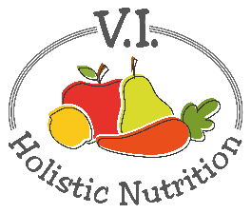
GARLIC AND HERBED LENTILS OVER PASTA
Here’s another variation of an Engine 2 recipe. Garlic, green beans, and green lentils, oh my! This meal is jam-packed with vibrantly fresh parsley and green beans, and the garlic adds a tang to the tongue. Green lentils can make any pasta plate more nutritious by loading it with iron, fiber and protein. A complete (and completely satisfying) dish awaits! Makes 1 medium serving.
Ingredients:

- ½ cup pasta, whole grain or gluten free
- ¼ cup green lentils, rinsed
- ¾ cup purified water
- 1 clove garlic, minced or diced finely
- ¾ cup green beans, cut into bite-sized pieces
- ½ red pepper, diced
- ¾ cup fresh parsley
- Sea salt and pepper to taste

Directions:
- Bring water and green lentils to a boil in a pot with a lid. Once boiling, reduce heat to medium-low, and simmer for 20-30 minutes, or until water is absorbed and green lentils have softened. Add more water if needed.
- Add the green beans and red pepper to the pot of green lentils 15 minutes into the cooking time. Cover the pot so they get lightly steamed.
- Cook the whole grain pasta per directions on the box.
- Add a little water to a small pot or pan and bring up to low heat. Add garlic and fresh parsley just to warm them (2-3 minutes). Do not allow the garlic to brown.
- Drain the whole grain pasta; plate it and top with green lentils and veggies, and top with the fresh parsley mixture. Add salt and pepper to taste.

