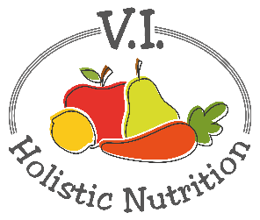
GINGER-LIME QUINOA SALAD
Here’s another altered recipe from Engine 2. This colorful salad is packed with veggies, antioxidants, fiber and plant protein. The green, herby dressing - made with cilantro, green onion and lime - makes a delicious addition to any variety of salads. Makes 1 medium serving.
Ingredients:
- ¼ cup quinoa, uncooked (or) ½ cup cooked quinoa
- 4 cups mixed greens
- ½ cup garbanzo beans (chickpeas)
- ½ red pepper, thin strips
- ½ cucumber, cut into matchsticks
- ½ cup purple cabbage, shredded
- 2 Tbs. cashews
- On the side: 1 orange
Dressing:
- 2 Tbs. cilantro, chopped
- 1 green onion, chopped
- Juice of ½ a lime, seeds removed
- 1 Tbs. rice vinegar
- ¼ tsp. ground ginger
- Sea salt and pepper to taste
Directions:
- In a small bowl, whisk together cilantro, green onion, lime juice, rice vinegar, ground ginger, and agave. Season with salt and pepper to taste.
- In a large bowl, combine mixed greens, cooked quinoa, beans, red pepper, cucumber matchsticks, purple cabbage and cashews. Pour on dressing and toss to coat. Serve with an orange on the side.

