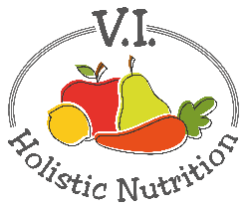
GREEN GOODNESS SOUP
This stew packs a Vitamin C punch, thanks to the combination of greens, red skin potatoes and frozen broccoli. And green lentils are filled with protein, fiber and folate, which supports red blood cell production and neurological function. Your whole body will thank you when you dig into this curry-inspired bowl of green goodness. Makes one medium serving.
Ingredients:
- A little purified water for ‘frying’
- 1 tsp cumin
- 1 tsp curry powder
- 1 tsp dried basil
- ¼ cup green lentils, rinsed
- 2 cloves garlic, minced or diced finely
- 1 ½ cups low sodium vegetable stock, or water and 1 low sodium veggie cube
- 2 red skin potatoes, diced in ½ inch cubes
- 1 cup frozen broccoli
- 2 kale leaves, chopped
- Sea salt and pepper to taste

Method:
- Add a little water to a large pot and bring up to medium-low heat.
- Stir in the curry powder, cumin, and dried basil. Heat for about 1 minute, stirring frequently.
- Add the green lentils, garlic, vegetable stock/broth (or water and veggie cube) to the pot and bring up to a low boil.
- After about 8 minutes, add the red skin potatoes to the pot. (You may want to add additional water here depending your preference, adding 1/2 cup at a time.)
- When the green lentils and red skin potatoes are soft (after 10-15 more minutes of cooking), add the kale and frozen broccoli.
- Cover and heat until the frozen broccoli is warm.
- Add more spice and herb as desired. Extra curry powder will give this soup an extra kick! Season to taste.

