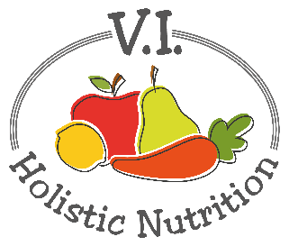
ITALIAN LENTILS AND SUMMER VEGETABLES
This refreshing power bowl is perfect for a throw-it-together dinner or a pack-it-up leftover lunch! Full of plant protein (from the quinoa and lentils) and vitamin C (thanks to the zucchini and tomato), this simple, delicious meal is simply nourishing. Makes 1 medium serving.
Ingredients:
- a little purified water for heating
- ½ can lentils, rinsed or 2/3 cup precooked lentils
- 1 cup premade quinoa
- 1 tsp. Italian seasoning blend
- 1 tomato, diced
- 1 small zucchini, diced
- 2 Tbs. fresh parsley, chopped
- 1 Tbs. fresh mint, chopped
- Sea salt and pepper to taste

Method:
- Add a little purified water to a pot and heat at medium low.
- Add lentils and heat until warmed through.
- Add quinoa and Italian seasoning and mix with lentils. Turn down burner to low and cover. You may need to add a little more water to prevent the quinoa from sticking.
- Add tomato and zucchini and heat through.
- Plate the lentil mixture and top with chopped parsley, mint and salt and pepper to taste.

