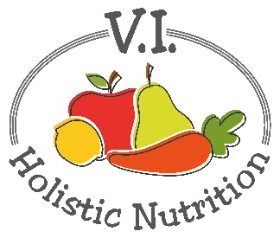
BERRY BANANA CRUNCH
This juice was adapted from 5lbs in 5 DAYS by Jason Vale. I have adapted it by making 2 juice bases at once and using frozen berries, a frozen banana, seeds and spinach in a blender to finish it. (makes 2 juices)
Ingredients (base)
- 4 Granny Smith apples, organic
Juice all above ingredients and transfer and divide the juice into 2 (2 cup) glass jars and seal and store in the fridge or freeze (if not using it that day).
When you are ready to serve transfer the juice to a blender or NutriBullet and add (per serving):
- 1 cup frozen berries
- 1 frozen banana
- 1 Tbs. mixed seeds pumpkin and sunflower, raw unsalted
- 1 handful of spinach
- Optional: add filtered water if it is too thick
Blend and serve immediately.

