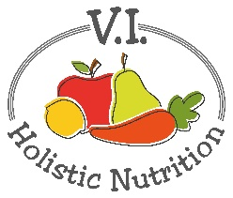
NATURE’S SUPER BLEND
This juice was adapted from 5lbs in 5 DAYS by Jason Vale. I have adapted it by making 2 juice bases at once and using avocado and spinach in a blender to finish it. (makes 2 juices)
Ingredients (base)
- 4 organic granny smith apples
- 1 small zucchini
- 2 limes, peeled
- 4 carrots
- 1 stalk celery
- ½ medium cucumber
- 2 inches broccoli stem
- 1 bell pepper
Juice all above ingredients and transfer and divide the juice into 2 (2 cup) glass jars and seal and store in the fridge or freeze (if not using it that day).
When you are ready to serve transfer the juice to a blender or NutriBullet and add (per serving):
- 1 handful of spinach
- ½ avocado
- 3 ice cubes (made from filtered water) optional
Blend and serve immediately.

