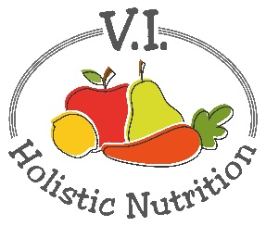
VEGGIE POWER SMOOTHIE
This juice was adapted from 5lbs in 5 DAYS by Jason Vale. I have adapted it by making 2 juice bases at once and using spinach, avocado and ice cubes in a blender to finish it. (makes 2 juice bases)
Ingredients (base)
- 4 Granny Smith apples, organic
- 1 lemon, peeled
- 1 stalk of celery
- ½ a medium cucumber
- 2 inches of broccoli stem
Juice all above ingredients and transfer and divide the juice into 2 (2 cup) glass jars. Seal and store in fridge for same day use or freeze.
When you are ready to serve transfer the base juice to a blender or NutriBullet and add (per serving):
- 2 large handfuls of spinach
- ½ avocado
- 3 ice cubes (made from filtered water)
Blend and serve immediately.

