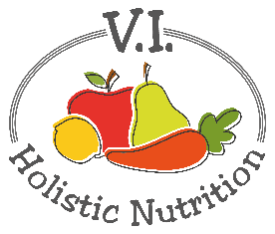
Kim’s Raw Energy Balls
Kim is one of the instructors at CSNN Nanaimo and teaches Sports Nutrition along with other courses. Here’s a great pick-me-up for low energy afternoons or after sports.
Ingredients:
- 2 ½ cups of rolled oats
- ½ cup pumpkin seeds
- 2 Tbs. sunflower seeds
- ½ cup almond or another nut butter
- 1/3 cup raw honey
- 2 Tbs. maple syrup
- 1 Tbs. chia seeds soaked in 2 Tbs. water
- ½ cup raisins or other dried fruit such as blueberries, cranberries, cherries, apricot, fig or dates
- Unsweetened sulfite free shredded coconut to coat
Method:
- In a food processor, puree ½ cup rolled oats and pumpkin seeds until powdery. Set aside.
- Combine remaining oats and sunflower seeds in food processor.
- Add soaked chia, almond butter, honey and maple syrup. Puree until well mixed.
- Add raisins and continue to puree until mixture comes together. It will become heavy and sticky.
- Rub coconut oil into your clean hands (to keep dough from sticking to hands) and roll mixture into balls, then coat in coconut shreds.
- Transfer to a sealed container for storage. They will last about a week on the counter, or in the refrigerator for up to 3 weeks.

