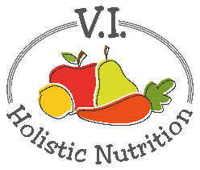
MINTY TABBOULEH
Here’s another recipe from Engine 2. Every bite of this refreshing - and refreshingly simple - dish is full of lemony zing and fresh veggie crunch! Makes 1 medium serving.
Ingredients:
- ¼ cup quinoa
- ½ cup water
- ½ cup canned cannellini beans, chick peas or other beans, rinsed and drained
- ¼ cup cherry tomatoes, quartered
- ½ cucumber, cut lengthwise, quartered and cut into small pieces
- 1 green onion, chopped
- 1 lemon, squeeze out the juice, remove seeds
- 2 Tbs. fresh mint, chopped
- 2 Tbs. fresh parsley, chopped
- Sea salt and pepper to taste
- 1-2 cups mixed greens
Method:
- Combine the quinoa with twice as much water in a pot with a lid. Bring the water to boil over high heat. Then turn down the heat to minimum, keep the pot covered, and cook for 20 minutes. Remove the pot from the burner and let sit an additional 5 minutes with the lid on. Fluff with a fork and set aside to cool.
- In a bowl, add cooked quinoa, drained beans, cherry tomatoes, cucumber, green onion, lemon juice, fresh mint, fresh parsley, and season with salt & pepper (if using).
- Serve the tabbouleh on a bed of fresh mixed greens.

