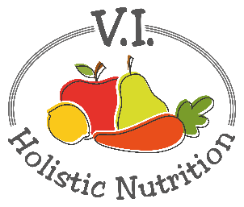
MOTLEY PASTA
At the end of particularly long day, there's nothing better than a simple, hot meal. Capers and herbs fill out this classic pasta and marinara dish. Packed with whole grains, protein and fiber, this dish is nutritionally and soulfully satisfying. Comfort food like this won't leave you overstuffed and full of regret. Instead, it will leave you nourished, light, and truly comforted. Makes one medium serving.
Ingredients:
- ½ cup whole wheat or gluten free pasta
- A little purified water for ‘frying’
- 2 cloves garlic, minced or chopped finely
- ½ can no salt diced tomatoes
- ¼ cup purified water
- ½ can chickpeas (garbanzo beans), rinsed
- 1 Tbs. capers
- 2 pinches sage
- 2 pinches thyme
- ¼ tsp. oregano
- Sea salt and pepper to taste
- 2 kale leaves, spins removed, roughly chopped

Method:
- Prepare the pasta according to the cooking instructions on the package.
- In a medium pot, heat frying water on low heat and add garlic.
- Cook for a minute, stirring frequently, until fragrant.
- Add tomatoes and water and allow to simmer on low heat uncovered for five minutes.
- Stir in the beans and remaining seasoning ingredients (capers, dried sage, dried thyme, dried oregano, and salt and pepper). Simmer for an additional 5 minutes.
- Then, stir in kale. Cook until kale is just wilted.
- Remove from heat and pour vegetable mixture over the prepared whole grain pasta. You're ready for dinner!

