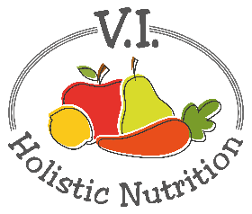
OPEN FACE PITA WITH VEGGIES AND HUMMUS
I find it more satisfying to use the pita bread as a base and pile everything on top and eat it with a knife and fork. This recipe is super easy and delicious and makes a satisfying yet light lunch. Makes 1 medium serving.
Ingredients:
- 1 whole wheat pita
- ¼ cup of hummus (preferably oil free)
- ¼ avocado, sliced
- 1 cup spinach leaves, stems removed
- 1 cup cherry tomatoes, sliced lengthwise
- 2 Tbs. fresh parsley, chopped
- ¼ lemon
- 2 pinches chili powder
- Sea salt and pepper to taste
Method:
- Place the whole wheat pita on a serving plate.
- Spread hummus on the pita.
- Evenly place the avocado slices, then spinach leaves, then halved cherry tomatoes on the pita.
- Top with the chopped fresh parsley
- Squeeze the juice from the lemon over the vegetables.
- Sprinkle on the chili powder and grind sea salt and pepper over the pita.

