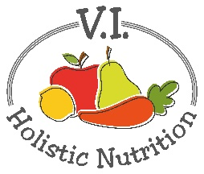
PASTA SALAD ITALIANO
You are going to love this colorful pasta salad. As usual it’s vegan, gluten free and uses healthful oils. This dish is great as a summer side dish or on a bed of greens for a light meal. Makes 4 servings.
Ingredients:
- 2 cups brown rice shell pasta, uncooked
- 10 cherry tomatoes, halved
- ½ cup black olives, sliced
- ¼ cup red onions, diced
- ½ small bell pepper (any color), diced
- 2 green onions, sliced
Dressing:
- 1 Tbs. oil (flax, hemp or grapeseed)
- 2 Tbs. olive oil
- 2 Tbs. red wine vinegar
- ½ tsp. dried basil
- ½ tsp. dried oregano
- ¼ tsp. garlic powder
- ½ tsp. sea salt
Method:
- Cook the shell pasta as directed on the package. I prefer packaged rice pasta over bulk as it remains al dente and is never mushy.
- While the pasta is cooking, chop the vegetables and set aside.
- Rinse pasta in cold water and drain well. Put in a large salad bowl with a lid and set aside or place in fridge to thoroughly cool.
- Add all dressing ingredients to a small bowl and whisk until smooth and combined.
- When the pasta is cool, add all the salad vegetables and dressing and toss to mix.
- Let the salad rest in the fridge for at least an hour to help develop flavors.

