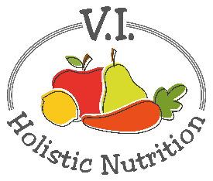
PASTA WITH CREAMY MARINARA
Here’s another recipe from Engine 2. This luscious pasta dish is quick, easy and finger-licking-good! When you blend savory nutritional yeast, protein-rich white beans and marinara together, the result is positively dreamy! This is sure to be your new go-to dish - for when you need a nourishing bowl of comfort food. Makes 1 medium serving.
Ingredients:
- 1 cup whole grain or gluten free pasta
- ¾ cup marinara, premade organic in a jar
- 1 pinch nutritional yeast
- 1 tsp Italian seasoning blend
- ½ cup cannellini beans (white kidney beans), rinsed
- Black pepper to taste
- Side Salad: 2 cups mixed greens and 1 Tbs. balsamic vinegar or your own dressing.

Method:
- Cook pasta according to directions on package.
- In a food processor or blender, combine marinara, nutritional yeast, Italian seasoning, and beans. Blend to desired consistency (pulse for a chunkier sauce or completely blend for a smooth sauce).
- Transfer to a saucepan and heat over low-medium until warm. Pour sauce over cooked pasta and sprinkle with additional nutritional yeast and black pepper.
- Serve with mixed greens tossed in balsamic vinegar, and enjoy!

