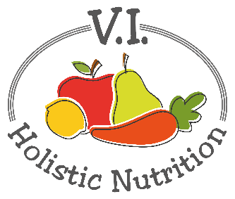
PASTA WITH GREENS AND BEANS
Here’s another recipe from Engine 2. This simple supper covers all the nutritious and tasty basics: greens, plant protein, whole grains and lots of savory flavors. Makes 1 medium serving.

Ingredients:
- 1 cup brown rice pasta
- A little purified water for ‘frying’
- 1 clove garlic, diced finely or minced
- ½ can cannellini beans (white kidney beans), rinsed
- ½ cup premade marinara (or jarred organic pasta sauce)
- 2 Tbs. fresh basil, chopped or 1 tsp. dried basil
- 1 Tbs. nutritional yeast
- 1 cup mixed greens
- Sea salt and pepper to taste

Method:

- Cook brown rice pasta according to package instructions.
- While the pasta is cooking, heat the ‘frying’ water in a skillet that is large enough to hold all the cooked pasta and the marinara sauce.
- Add garlic and sauté until fragrant.
- Add the marinara sauce, fresh basil, beans and nutritional yeast.
- Add the mixed greens and stir.
- Cook until the sauce is hot and the mixed greens are starting to wilt but still vibrant.
- Drain the brown rice pasta and add it you’re your sauce.
- Mix and spoon into your bowl. Enjoy!

