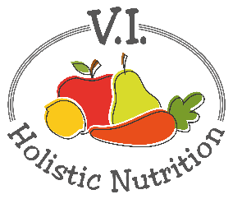
Penne with Tomato-Mushroom Cream Sauce
This recipe is from The Forks Over Knives Plan by Pulde and Lederman. I got this book after watching the documentary Forks Over Knives which discusses the merits of a plant-based lifestyle. I recommend the book and the documentary for anyone looking for information about a plant based lifestyle. This recipe makes about 11 cups and is a fat free recipe.
Ingredients:
- 12 ounces (390 grams/6 cups) whole-grain penne pasta (or brown rice pasta)
- 1 medium yellow onion, diced
- 1-pound mushrooms (5 cups lightly packed), trimmed and sliced
- 4 cloves garlic, minced or diced finely
- 2 tsp. dried thyme
- 1 (28 oz./796 ml) can crushed tomatoes, drained
- 1 cup unsweetened unflavored plant milk
- 1 cup fresh chopped basil (or 2 Tbs. dried)
- Sea salt and freshly ground black pepper
Method:
- Bring a large pot of water to a boil. Cook the pasta according to the package instructions. Drain and set aside.
- Meanwhile, in a large sauté pan over medium heat, cook the onion and mushrooms, stirring occasionally and adding water 1 to 2 tablespoons at a time as needed to keep the vegetables from sticking, until the onion is translucent and beginning to brown, 7 to 8 minutes.
- Add the garlic and thyme, and cook for 1 minute. Add the crushed tomatoes with their juice and simmer for 10 minutes, stirring occasionally.
- Add the plant milk, the cooked pasta, the basil, and salt and pepper to taste and toss until well coated. Taste and adjust the seasoning. Cook until heated through, about 1 minute. Serve hot.
- Optional: This is a lot of pasta for two people. So what I do, is make the sauce and freeze it in small glass containers and make the pasta as needed (1-1/2 cups dry per serving).

