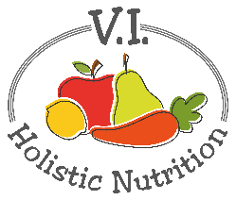
QUICK BROWN RICE CINNAMON BREAKFAST BOWL
Here’s another recipe from Engine 2. Eating whole grains with breakfast is a great way to start the day on the right foot! You might not think to have brown rice for breakfast, but the whole grain pairs perfectly with naturally sweet dates, smooth pumpkin seeds and creamy unsweetened soy/nut/rice milk for a power-packed first meal. It gets a little dressed up with some cinnamon spice, for something real nice! Makes one medium serving.
Ingredients:
- ¾ cup precooked brown rice
- ½ cup unsweetened plant milk
- 2 pinches cinnamon
- 2 dates, chopped
- 1 Tbs. pumpkin seeds
Method:
- Steam the precooked rice to heat it up.
- Put the rice in a bowl, add cinnamon and mix through.
- Add plant milk, dates and pumpkin seeds.
- Stir to mix and enjoy!

