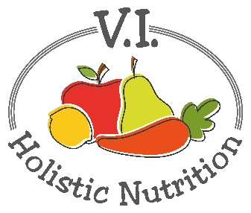
QUINOA TABBOULEH
Here's another great recipe from FMTV. Perfect for a Spring lunch.
Ingredients
(use organic ingredients where possible)
- 1 cup cooked quinoa - I buy mine from Bulk Barn.​​
- 1 medium tomato, finely diced
- 1 cup parsley, finely chopped
- 1/4 medium red onion, finely diced
- 2 Tbs. extra virgin olive oil - try to buy cold-pressed.
- 2 lemons, juiced - or just squeezed.
- Sea salt to taste
- 1 cup cooked chickpeas.

Method:
​​1. In a large bowl, mix together the cooked quinoa, chopped tomatoes, onion, parsley, olive oil and lemon juice. (I add my chickpeas here).
2. Mix well and add salt to taste.
3. Serve on a bed of fresh mixed greens or spinach.
​Serve it as a main, a side dish or as a filling for bell peppers, lettuce cups or wraps.
Nutritional Information:
Naturally gluten free, a complete protein and a source of iron, B-vitamins, magnesium, phosphorus, potassium, calcium, vitamin E and fiber, quinoa is a nutritional powerhouse!

