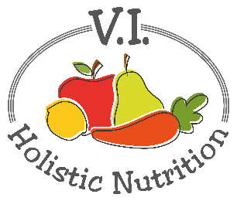
RAW VEGAN CASHEW SOUR CREAM
Raw cashews are amazing! If you go to any raw food restaurant, they use raw cashews to make sour cream and to make creamy sauces and dressings. This recipe is a variation from Savanna at glutenfreepantry.com. If you don’t have time to soak the cashews, you can double the amount of water but it may be more grainy than creamy.
Ingredients:
- 1 cup raw cashews, soaked overnight
- ¼ cup + 2 Tbs. fresh lemon juice
- ½ tsp. sea salt
- 1 tsp. nutritional yeast
- ½ cup purified water
Method:
- Put all the ingredients into a blender. I use my Veggie Bullet sauce cup as the motor is great and really liquifies the nuts.
- Blend on high and scrape down the sides periodically until the mixture is very smooth and creamy.
- Transfer to an airtight glass container and store in the fridge or use immediately.
- This recipe stores well in the fridge but try to use it up within a week as it starts to resemble and have the consistency of the wall plaster.

