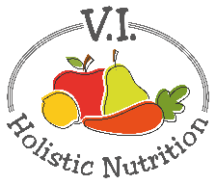
Raw Macaroons
Makes about 24
Ingredients:
- 1 cup almond flour
- 2 cups unsweetened sulfite-free coconut flakes
- 4 Tbs. maple syrup
- 4 Tbs. coconut oil
- 2 tsp. pure vanilla extract
Method:
- In a large bowl, combine almond flour and coconut flakes.
- On minimum (2) melt coconut oil in a small pot.
- Add maple syrup and vanilla extract to coconut oil and stir to mix.
- Add coconut oil, maple syrup and vanilla extract to flour mixture.
- Mix until combined.
- Line a cookie sheet with parchment paper and with clean hands massage a little coconut oil into your hands.
- Scoop out rounded teaspoon sizes of mixture into you hands and press together to form a ball or whatever shape you want. Place ball on parchment paper and continue this process until you have used up all the mixture.
- Place the cookie sheet into the fridge or freezer to set for about 30-60 minutes.
- Store in the fridge or freezer in a covered glass container.

