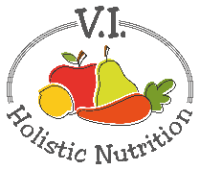
RAW PAD THAI
Ingredients:
- 2 carrots, shredded
- 1 cup zucchini, shredded
- ¼ head cabbage, thinly sliced
- 1 small red pepper, thinly sliced
- ½ cup bean sprouts (optional)
- ½ cup cilantro, chopped
- 8 mint leaves, chopped
- 1 green onion, chopped
- Juice of ½ a lime
- ¼ cup chopped cashews, for topping
Method:
- Prepare all the vegetables and place in a large bowl.
- Add the lime juice and toss.
- Save the cashews until after you dress the salad.
Dressing Ingredients:
- 1-inch fresh ginger, chopped
- 1 garlic clove, chopped
- 1 Tbs. tamari or other soy sauce
- 1 Tbs. apple cider vinegar
- ¼ cup raw cashews
- 2 Tbs. extra virgin olive oil or flax oil
- Juice of ½ a lime
- 1 tsp. maple syrup
- ¼ tsp. red chili pepper flakes
- Sea salt and pepper to taste
Method:
- Put all ingredients in a NutriBullet or blender and blend until smooth.
- Pour dressing over salad and toss to mix.
- Top with cashews and serve.

