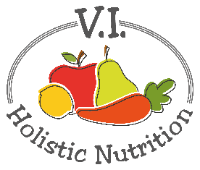
Raw Protein Bars
Here’s a delicious recipe for a raw protein bar which is featured in The Lifehouse calendar (2017). It was originally given to Heather-Lynn by Cathy Chenier from Manitoba. I have revised it slightly.
Ingredients:
- 1 cup hemp hearts
- 1 cup unsweetened coconut flakes
- 1 cup almond flour
- ¾ cup dried goji berries
- ½ cup raisins
- ½ cup vegan protein powder (vanilla or chocolate)
- 3 big heaping Tbs. cocoa or raw cacao powder
- 2 Tbs. ground flax seed
- 10 Tbs. melted coconut oil
- 4 Tbs. raw honey
Method:
- Mix all the dry ingredients together.
- Warm to melt the coconut oil and honey.
- Add the oil to the dry ingredients and mix until combined.
- On a baking sheet lined with parchment paper, turn out the mixture and shape with your hands into a square and flatten.
- Score the mixture with a knife to make it easier to cut into squares after it sets.
- Let set in the fridge or freezer for about half an hour.
- Cut into squares and store in the fridge or freezer.

