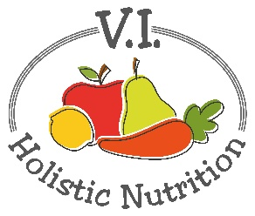
RED BEAN COLESLAW
Here’s an adapted recipe from La Dolce Vegan! I eliminated the sugar and reduced the amount of Vegenaise. You can buy Vegenaise (vegan mayonnaise) in the refrigerated section of your grocery store with other fresh dressings. Imitation bacon bits are made from vegetable protein. Buy a good quality one from the health food store or omit them from the recipe.
Salad Ingredients:
- ½ head cabbage, thinly sliced (approximately 3-4 cups)
- ½ red onion, diced
- 1 large celery stick, sliced
- 1 can kidney beans, rinsed and drained (or 1 1/3 cups precooked beans)
- Optional: ½ cup imitation bacon bits
Dressing:
- ½ cup Vegenaise
- ¼ cup red wine vinegar
- 2 Tbs. fresh parsley, chopped
- 1 tsp. dried oregano
- ½ tsp. sea salt
- ½ tsp. ground black pepper
Method:
- Prepare the dressing beforehand. Add all ingredients to a small bowl and whisk to mix and store in the fridge while you prepare the salad.
- In a large bowl, add all salad ingredients.
- Add the dressing and toss well.
- Store in the refrigerator for about and hour before serving to give the flavors a chance to mix well.

