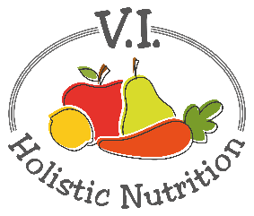
Righteous Orbs
Raw Energy Snacks

A version of this recipe was given to me by Dona Bradley, who is the academic director of CSNN, Nanaimo.
Ingredients:
- 1/3 cup hemp hearts
- 2 cups nuts of your choice (walnuts, almonds, pecans, etc.) (or) 2 cups almond flour if you don’t have a food processor.
- 1 cup raisins
- 2 Tbs. maple syrup or honey
- 1 Tbs. coconut oil + some to grease hands when rolling
- 1 tsp. cinnamon
- ¼ tsp. salt
Method:
- Place a sheet of parchment paper on a baking sheet. Set aside.
- Measure out hemp seeds onto a small plate and set aside.
- In a food processor, add nuts and chop until fine.
- Add all remaining ingredients and blend until the mixture starts to pull away from the sides of the processor and forms a dough.
- Scoop out teaspoons of dough and roll into balls with clean coconut oil covered hands.
- Roll each ball in hemp seeds until coated.
- Place balls on the lined baking sheet and refrigerate for one hour before serving.

