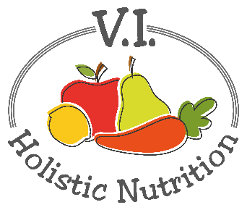
SAVORY LENTIL-VEGGIE PITA POCKET
Here’s another recipe from Engine 2. We love lentils first and foremost because they're delicious. And thankfully, they're also a good source of iron and plant protein! This simple pita - with flavorful lentils and fresh veggies in the mix - is a tasty and nourishing meal that's super simple to throw together. (Pro Tip: Keep some napkins handy while you munch on this lunch!) Makes 1 medium serving.
Ingredients:
- a little purified water to prevent sticking
- ½ can lentils or 2/3 cup pre-cooked lentils
- 1 bell pepper, diced
- 1 tsp. chili seasoning mix
- 1 cup baby kale
- Sea salt and pepper to taste
- 1 whole wheat pita
- Optional: ¼ avocado, cayenne pepper
- 1 apple (for dessert)

Method:
- Add a little water to a small pot and heat on medium low.
- Heat the lentils until warm.
- Mix in the chili mix seasoning and baby kale to cook with the lentils. Add salt and pepper to taste.
- Add the bell pepper to the lentils. When warm, scoop the lentil and veggie mixture into the pita pocket. Add optional ingredients if desired.
- Enjoy with fresh fruit on the side.

