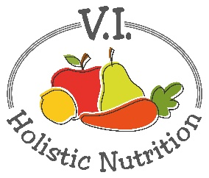
SKIN BEAUTY SALAD
Here's another recipe from the FMTV 21 day program. I double the amount of salad vegetables. Especially the greens, I use one small clam shell of organic mixed greens. There's enough dressing for a really big salad like the one pictured below. There's plenty for two people or it's a great salad to take to a party. If you are going to make one portion for yourself, store half the dressing in a sealable glass container and keep the avocado pit to place in the center of the dressing to stop the dressing from going brown.
Ingredients
​(use organic ingredients where possible)
​2 handfuls of bitter greens (arugula, dandelion and endive)
1 carrot, grated
1 cucumber, sliced
​1/4 red onion, finely diced - the original recipe calls for 1/2 a red onion which I find too much. (And so does everyone I talk to after lunch!)
Optional: 1 radish
1 cup cooked chickpeas
Dressing
​1 lime, juiced
1 avocado - I use a big one.
​1 Tbs. apple cider vinegar - Bragg's is the best.
Pinch of cayenne pepper
​1 tsp. raw honey - Fredrich's is the best.
​1 handful fresh, soft herbs (works best with dill, cilantro or basil leaves)
​1/4 tsp. salt
Method
- ​To make the dressing, add to the blender lime juice, avocado, apple cider vinegar, cayenne pepper, honey, herbs and salt.
- Blend until smooth, you may need to add a dash of water to facilitate blending.
- Adjust seasoning to taste.
- In a large bowl, arrange the leaves, cucumber, carrot, radish, chickpeas and onion.
- Dollop dressing generously on your salad. Mix through before eating.

