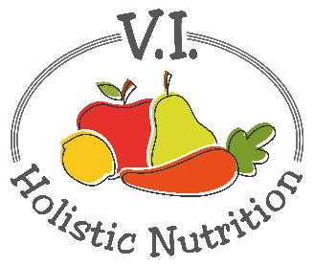
SPLIT PEA SOUP
This flavorful soup is taken from the book Eating Alive: Prevention Thru Good Digestion by Dr. Jonn Matsen N.D. He works out of Vancouver and this book is one of our course books at CSNN. There are lots of good plant based recipes in this book which is also dairy and gluten free.
Ingredients:
- 2 ½ cups green split peas, rinsed
- 7-9 cups purified water or vegetable stock
- 2 bay leaves
- 2 medium onions, diced small
- Optional: 1-2 potatoes and/or 2 carrots chopped small and pre-steamed. (I prefer carrots as the potatoes taste a little too starchy for me.)
- 2 Tbs. of olive oil
- 2 Tbs. wheat-free tamari soy sauce
- 2 tsp. dried parsley
- 1 ½ tsp. sea salt
- 1-2 tsp. honey (to balance the flavors)
- 1 tsp. each: basil, oregano, mint
- ½ tsp. each: thyme, kelp powder, red pepper flakes
- ¼ tsp. each: marjoram and savory
Method:
- In a large soup pot, bring rinsed split peas, bay leaves and purified water to a boil then reduce heat to medium and cook for about 1 ½ hours or until the peas totally dissolve into the liquid.
- While the peas are cooking, pre-steam the potatoes/carrots.
- In a small frying pan, add oil and onions and cook the onions until they are translucent (about 8 minutes).
- Add onions, steamed vegetables, tamari, parsley, sea salt, honey, and herbs to the pot and cook over a medium to low heat for about 25 minutes to develop the flavors. If it tastes flat, add vegetable bouillon.
- Stir the soup occasionally, keeping the heat low so it doesn’t stick or burn.
- Remove bay leaves and serve.
- Optional: I blend my soup with an immersion blender for a thick, smooth texture.

