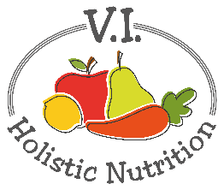
STRAWBERRY OAT AND CHIA PUDDING
This pudding is all about the amazing talents of chia seeds. High in protein and full of fiber and omega-3 fatty acids, chia seeds are a deliciously healthy way to magically make a luscious pudding. Top it off with fresh or frozen strawberries for a burst of fruity sweetness and Vitamin C in every bite! Makes 1 medium serving.
Ingredients:
- ½ cup rolled oats
- 1 Tbs. chia seeds
- 1 cup boiling purified water
- 1 cup strawberries, fresh or frozen and thawed, sliced
- ¼ tsp. cinnamon
- 1 date, chopped
Method:
- Add oats of a jar or bowl.
- Stir in chia seeds into oats before adding water to keep from clumping.
- Pour boiling water over the oats, cover and let sit for 5 minutes.
- Add the berries, cinnamon and date.
- Stir to mix and enjoy.
Note: Fresh strawberries aren't always available, but frozen strawberries - or any other berry - will work just fine in their place.

