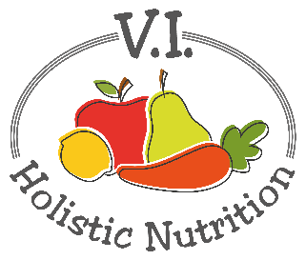
TUSCAN WHITE BEANS AND KALE
Here’s another recipe from Engine 2. Take a trip to Tuscany - in no time at all! This throw-it-together dinner is a great go-to meal for those nights when you want something comforting, nourishing and quick. Protein-rich white beans, whole-grain pasta and superfood kale make up the tasty basics here. With garlic and a dash of salt and pepper, the simple flavors of this dish can really shine! Makes 1 medium serving.
Ingredients:
- 1 cup whole wheat or gluten free pasta
- A little purified water for ‘frying’
- 1/8 onion, chopped
- 1 garlic clove, minced or finely chopped
- ½ can cannellini beans (white kidney beans)
- 1 tsp. Italian seasoning blend
- 1 tomato, diced
- 2 cups kale, chopped
- Optional: olive oil to taste (Don’t cook with it just add a tsp. for flavour at the end.)
- Sea salt and pepper to taste

Method:
- Cook the pasta according to the directions on the box.
- In a medium pot, add water and heat to medium low.
- Add onions and cook for 8 minutes until translucent.
- Add garlic and cook for another minute.
- Add beans, Italian seasoning, tomato and simmer for 5 minutes.
- Add kale and simmer for an additional 5 minutes.
- Plate the pasta and top with the bean mixture.
- Add sea salt, pepper and a dash of tasty olive oil as desired.

Note: heating oils and exposing them to air and sunlight changes the molecular structure which can turn a healthy oil into an unhealthy oil. So, if you are going to use oils, store in dark glass bottles and add after cooking for flavour.

