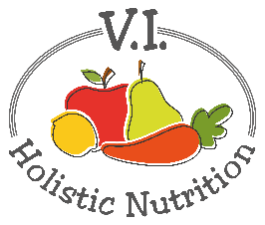
VEGGIE STIR-FRY WITH RICE
Here's another recipe from FMTV. Simple is sometimes best! A vegan stir-fry thrown into the weekly meal routine is a great way to use up leftover vegetables and up your daily fiber intake. Enough for 2 small meals or 1 big meal.
​Ingredients:
(use organic ingredients where possible)
- 2 tsp. sesame oil
- 1 thumb-sized piece of ginger, finely chopped
- 1 garlic clove, finely chopped
- 1/2 cup broccoli florets, chopped small
- 1 shallot or spring onion, thinly sliced
- 1 small bok choy, roughly chopped
- 1/2 red bell pepper, thinly sliced
- 2 Tbs. tamari
- 1 cup cooked rice (basmati or brown)
Method:
​​(As this cooks so fast, always prepare all ingredients beforehand)
- Cook rice as per package instructions.
- Heat wok or fry pan over heat (6 is the highest you should heat oil)
- Add sesame oil and, when hot, add ginger and garlic to fry for 1 minute.
- Add broccoli and spring onion and toss for 1 minute.
- Add bok choy, bell pepper and toss for 1 minute.
- Add tamari and cover for 1 minute.
Serve on a bed of cooked rice. Garnish with raw sesame seeds (optional).

