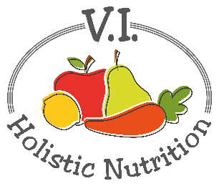
ZUCCHINI POMODORO
Here’s another great recipe from FMTV. It’s great if you are craving spaghetti but want a raw vegan option. I’ve tweaked it a little. This is a great salad for lunch or as a different kind of salad to take to a potluck.
Ingredients:
- 2 zucchinis
- 1 large tomato
- 6 soaked, sun-dried tomatoes
- ¼ cup virgin olive oil
- 2 cloves garlic
- 1 tsp. raw honey
- 2 Tbs. fresh basil
- 1 tsp. sea salt
Method:
- Spiralize the zucchini into noodles, or with a peeler into ribbons, and place in a large serving bowl. Tip: line the bowl with paper towel and let zucchini rest for 15 minutes to dispel excess water into the paper towel. Then discard paper towel.
- For the sauce, place remaining ingredients in a food processor/blender until smooth.
- To serve, place the zucchini noodles into bowls and pour the raw sauce over the top, just like you would for a bowl of pasta.
Tip: You can blanch the noodles in boiling water for two minutes so you can serve this dish hot in winter.
Health Benefits:
Zucchini provides you with lutein and zeaxanthin, two carotenoids that promote healthy eyesight. They’re also a source of magnesium, folate and fiber.

