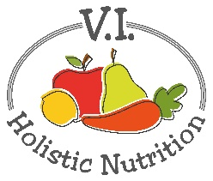
Delicious Green Smoothie
Here's a FMTV green smoothie recipe from their 21-day program. It makes a filling breakfast.
Ingredients:
​​(use organic ingredients where possible)
- ​​1 banana, fresh or frozen
- 1/2 avocado
- handful of spinach
- 1 serving protein powder*
- 1 date, pitted
- 14 oz. plant-based unsweetened milk (coconut, hemp, almond, cashew or rice)
- 1/2 tsp. cinnamon
​Add all ingredients to a blender or Nutribullet and blend until smooth.
​* Avoid protein powders containing sugar, artificial sweeteners, additives and artificial flavors. Opt for plant-based protein powder using only natural ingredients.
​

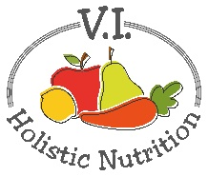

Berry Smoothie
Here's another great recipe from FMTV. I've changed it up a little by adding some protein powder to boost my protein.
Ingredients:
(use organic ingredients where possible)
- ​1 handful of baby spinach leaves
- 1/2 small avocado
- 1 cup frozen organic berries
- 1 banana
- 1.5 cups of coconut water or purified water
- Optional: 1 scoop of vegan protein powder
- Optional: ice cubes made from purified water
Method:
- ​Blend all ingredients together
- Enjoy!
Why it's so good for you:
Berries are rich in antioxidants which help your body fight cell damage, premature aging and oxidative stress linked to the development of numerous diseases! All fruits and vegetables contain antioxidants, but nutrient-rich berries are some of the absolute best sources! They're also a great source of fiber, and when combined with avocado, banana and the hydration from coconut water, this smoothie mix will also help detoxify your bowels and replenish electrolytes.

